**Assignment – 3**

Write SQL command for the following:

1. Create table employee(eid, name, address, post, email, age, team_name) with the following constraints:
   1. eid PRIMARY KEY.
   2. user must enter the name, post and team_name.
   3. One employee can have only one email address.
   4. age : should be more than 20 (Note: Use CHECK constraint)
   5. If user does not enter the team_name then by default make it “Unicorn”.

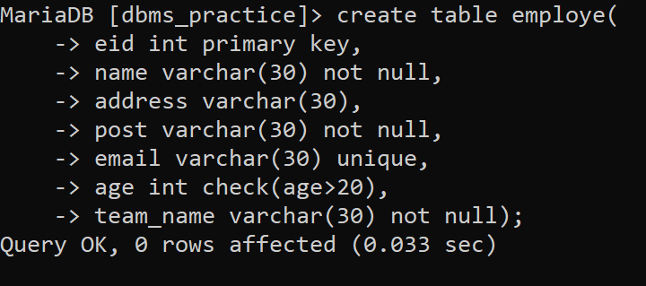



1. Insert details of 15 employees using multi insert method.

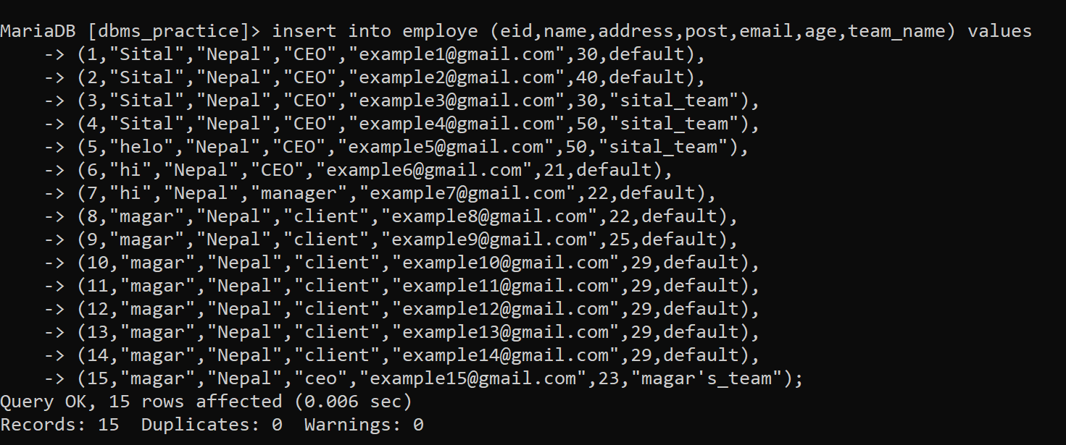

1. Select all the details of the employees whose age is greater than 25.

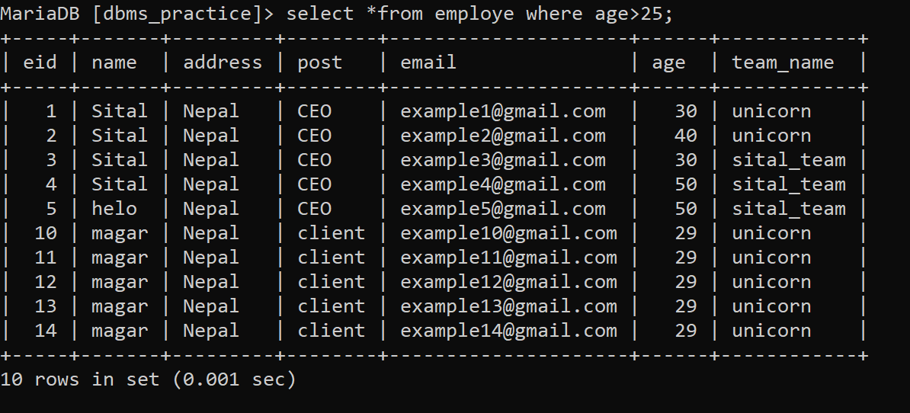

1. Select id, name and post of all the employees who live in Ghorahi



1. Select id, name and email of the employees whose post is manager and age is less than 40.

